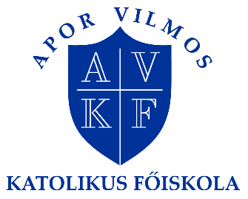
INTERNATIONAL ERASMUS + SEMESTER
4 February-17 May 2019
APPLICATION FORM
Application deadline: 1 December 2018
Please send this form to: Mr Zsolt Szabó international coordinator, erasmus@avkf.hu
Personal data

Family name

First name(s)

Sex | ☐ Male  ☐ Female
Date of birth (month/day/year)

Nationality

Home address

Mobile phone (incl. country and area code)

E-mail

Further things useful for us to know (special diet etc.)

Home institution
Official name and address of your home university / institution

Your international coordinator ’s name
phone number
e-mail
Your field of specialization | ☐ preschool  ☐ primary school  ☐ secondary school  ☐ social educator  ☐ other; please, specify:
Language competence
Mother tongue
English language competence: | ☐ poor  ☐ fair  ☐ good
For further information please contact Mr Zsolt Szabó international coordinator, erasmus@avkf.hu

