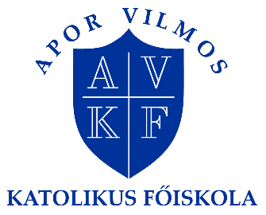
Talent Support through Tales and Drama
INTERNATIONAL WEEK
8-12 APRIL 2019
APPLICATION FORM
APPLICATION DEADLINE: 18 November 2018
Please send this form to: erasmus@avkf.hu
Further information: Mr Zsolt Szabó, Erasmus coordinator, erasmus@avkf.hu
Apor Vilmos Catholic College
2600 Vác, Konstantin tér 1-5.
Hungary
Personal data
Name (family name, first name)
☐ Male
☐ Female
Date of birth (month/day/year)
Home address
Street
Postal Code, City
Country
Mobile phone (incl. country and area code)
E-mail
Further things useful to know for us (special diet)
Home institution (Official name and address of your home university / institution)
Your international coordinator
Name
Phone
E-mail
Field of specialization
☐ preschool
☐ primary school
☐ secondary school
☐ social educator
☐ other
Language competence
Mother tongue:
English language competence:
☐ poor
☐ fair
☐ good

